Name of the Student: G. Manasa Goud | Academic Year: 2025-26
Student Registration Number: 241U1R3007 | Year & Term: II & II
Study Level: UG | Class & Section: CSE(DS)-2A
Name of the Course: DISCRETE MATHEMATICS | Name of the Instructor: Kishore Reddy P
Name of the Assessment: ASSIGNMENT 2 | Date of Submission: 17-12-2025

ASSIGNMENT 2

1.Define a graph. Explain basic graph terminology such as vertex, edge, degree of a vertex, order, and size of a graph with suitable examples.
1. Graph and Basic Terminology
A graph $G$is an ordered pair
$$G=(V,E)$$
where
- $V$= set of vertices (nodes)
- $E$= set of edges (connections between vertices)
Basic Terminology
- Vertex (Node): A point in a graph
Example: $V=\{A,B,C\}$
- Edge: A line joining two vertices
Example: $AB$
- Degree of a vertex: Number of edges incident on that vertex
Example: If A is connected to B and C, then $deg⁡(A)=2$
- Order of a graph: Number of vertices
Example: $∣V∣=4$
- Size of a graph: Number of edges
Example: $∣E∣=5$
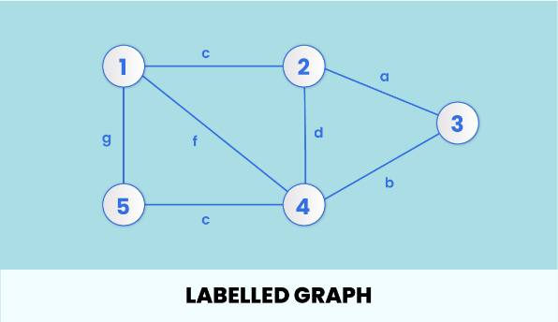
2. Explain the following types of graphs with definitions and neat examples:
(a) Simple graph
(b) Multigraph
(c) Pseudograph
Types of Graphs
(a) Simple Graph
- No loops
- No multiple edges
Example: Triangle graph
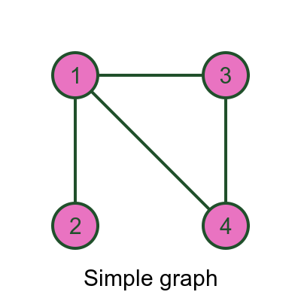
(b) Multigraph
- Multiple edges allowed between the same vertices
- No loops
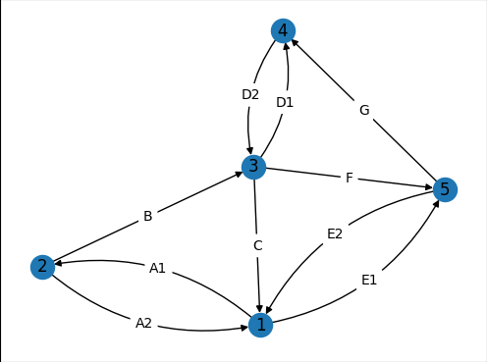

(c) Pseudograph
- Loops allowed
- Multiple edges allowed
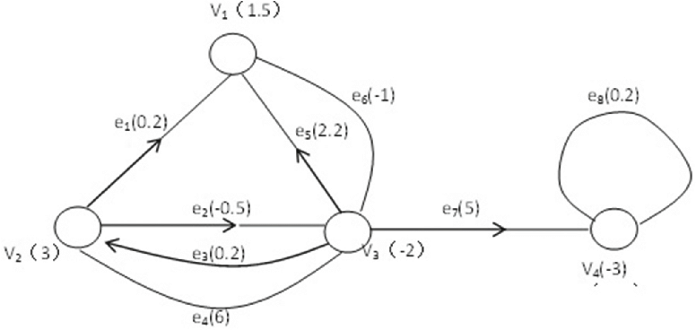

3. Define and explain the following special graphs:
(a) Complete graph
(b) Null graph
(c) Regular graph
Give one example for each.
Special Graphs
(a) Complete Graph
- Every pair of vertices is connected
- Denoted by $K_{n}$
Example: $K_{4}$
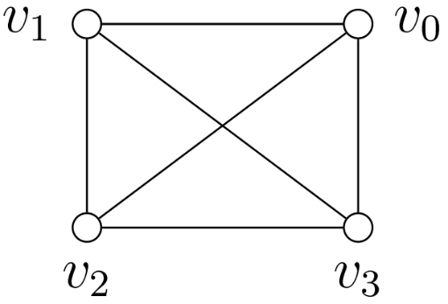
(b) Null Graph
- Graph with vertices but no edges
Example: $N_{4}$
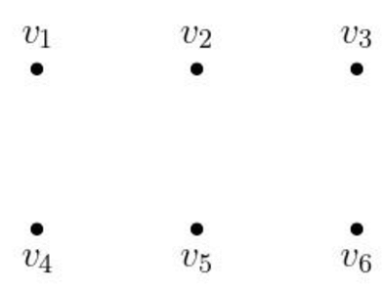

(c) Regular Graph
- All vertices have the same degree
Example: Cycle graph where every vertex has degree 2
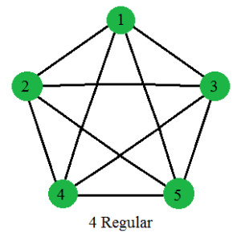
4. Explain cycle graphs and wheel graphs. Compare their properties and illustrate each with a suitable diagram.
Cycle Graph and Wheel Graph
A cycle graph is a graph in which:
- All vertices are connected in a closed circular path
- Each vertex is connected to exactly two other vertices
A cycle graph with $n$vertices is denoted by:
$$C_{n}(n≥3)$$
Properties of Cycle Graph
- Number of vertices = $n$
- Number of edges = $n$
- Degree of every vertex = 2
- It is a connected and regular graph
- It is bipartite only when $n$is even
- It is a planar graph

Example
$C_{5}$(cycle with 5 vertices)
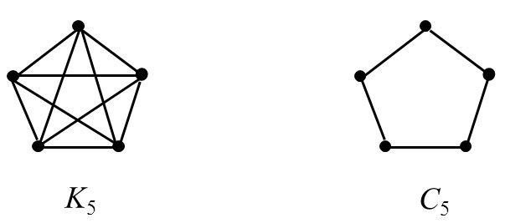
Wheel Graph $W_{n}$
A wheel graph is obtained by:
- Taking a cycle graph $C_{n-1}$
- Adding one central vertex
- Connecting this central vertex to all vertices of the cycle
A wheel graph with $n$vertices is denoted by:
$$W_{n}(n≥4)$$
Properties of Wheel Graph
- Number of vertices = $n$
- Number of edges = $2(n-1)$
- Degree of central vertex = $n-1$
- Degree of each outer vertex = 3
- It is a connected graph
- It is planar
- It is not bipartite (contains triangles)
Example
$W_{6}$(cycle of 5 vertices + 1 central vertex)

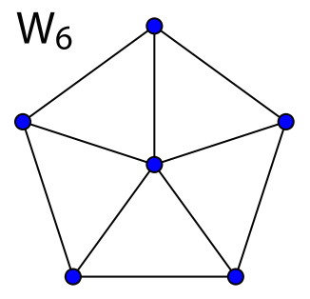

Comparison
Property | Cycle Graph | Wheel Graph
Degree | All vertices = 2 | Center has high degree
Edges | n | 2n
Planar | Yes | Yes

5. Define bipartite graph and complete bipartite graph. State the conditions for a graph to be bipartite and give suitable examples.
Bipartite Graph
A graph $G=(V,E)$is called a bipartite graph if its vertex set $V$can be divided into two disjoint sets $V_{1}$and $V_{2}$such that:
- Every edge of the graph joins a vertex in $V_{1}$to a vertex in $V_{2}$
- No edge joins two vertices within the same set
- In other words, edges are allowed only between the two sets, not within a set.
Example of Bipartite Graph
Let:
- $V_{1}=\{A,B\}$
- $V_{2}=\{1,2,3\}$
Edges: $\left\{A1 , A2 , B2 , B3\right\}$
Since no edges exist between vertices of the same set, the graph is bipartite.
Conditions for a Graph to be Bipartite
A graph is bipartite if and only if:
- It contains no odd-length cycles (no cycles of length 3, 5, 7, etc.)
Explanation
- Even cycles → bipartite
- Odd cycles → not bipartite
Example:
- Cycle graph $C_{4}$(square) → bipartite
- Cycle graph $C_{3}$(triangle) → not bipartite

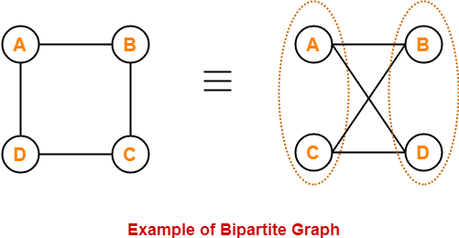

Complete Bipartite Graph
A complete bipartite graph is a bipartite graph in which:
- Every vertex in set $V_{1}$is connected to every vertex in set $V_{2}$
It is denoted by:
$$K_{m,n}$$
where:
- $m=∣V_{1}∣$
- $n=∣V_{2}∣$
Example of Complete Bipartite Graph
- $K_{2,3}$:
  - Set $V_{1}=\{A,B\}$
  - Set $V_{2}=\{1,2,3\}$
  - Each vertex in $V_{1}$is connected to all vertices in $V_{2}$

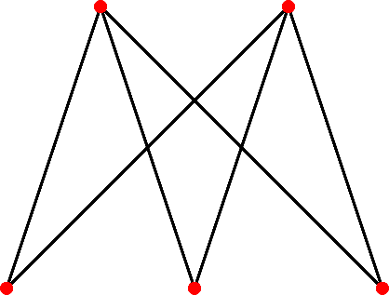

6. Explain the concept of subgraphs. Distinguish between proper subgraph and spanning subgraph with examples.
Subgraph
A graph formed from a subset of vertices and edges of a graph.
Let $G=(V,E)$be a graph.
A graph $G^{'}=(V^{'},E^{'})$is called a subgraph of $G$if:
- $V^{'}⊆V$(subset of vertices), and
- $E^{'}⊆E$(subset of edges),
where every edge in $E^{'}$has both its endpoints in $V^{'}$.
Proper Subgraph
A proper subgraph of a graph $G$is a subgraph that is not equal to $G$.
That is, it has:
- fewer vertices, or
- fewer edges, or
- both fewer vertices and edges than $G$.
Example
Let $G$be a graph with vertices $\left\{A , B , C , D\right\}$and edges
$\left\{AB , BC , CD , DA\right\}$.
A proper subgraph $G^{'}$can be:
- Vertices: $\left\{A , B , C\right\}$
- Edges: $\left\{AB , BC\right\}$
Since $G^{'}≠G$, it is a proper subgraph.

Spanning Subgraph
A spanning subgraph of a graph $G$is a subgraph that:
- contains all the vertices of $G$, and
- may have fewer edges than $G$.
Example
Let $G$have vertices $\left\{A , B , C , D\right\}$and edges
$\left\{AB , BC , CD , DA , AC\right\}$.
A spanning subgraph $G^{'}$can be:
- Vertices: $\left\{A , B , C , D\right\}$
- Edges: $\left\{AB , BC , CD\right\}$
All vertices are included, but some edges are removed → spanning subgraph.

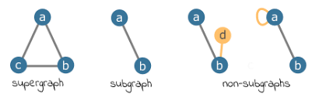
7. Define incidence matrix and show how to construct the incidence matrix of a given graph. Explain its properties.
For a graph $G=(V,E)$with
- $∣V∣=m$vertices and
- $∣E∣=n$edges,
the incidence matrix of $G$is an $m×n$matrix $I=[i_{ij}]$where:
$$i_{ij}=\left\{\begin{matrix}1, & \text{if vertex }v_{i}\text{ is incident to edge }e_{j} \\ 0, & \text{otherwise}\end{matrix}\right.$$
Construction of Incidence Matrix
Step-by-Step Method
- List all vertices of the graph as rows.
- List all edges of the graph as columns.
- Put 1 if a vertex is incident to an edge.
- Put 0 otherwise.

Example Graph
Consider a graph with:
- Vertices: $V=\{A,B,C\}$
- Edges:
  - $e_{1}=AB$
  - $e_{2}=BC$
  - $e_{3}=CA$
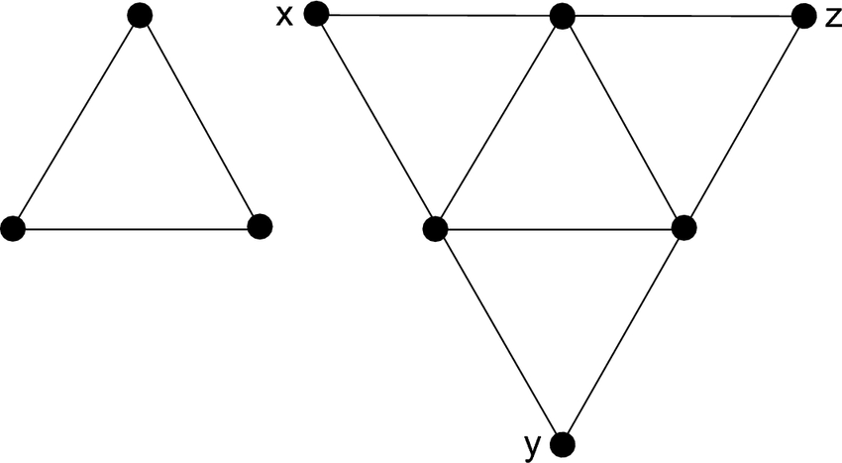
Incidence Matrix
 | $e_{1}$(AB) | $e_{2}$(BC) | $e_{3}$(CA)
A | 1 | 0 | 1
B | 1 | 1 | 0
C | 0 | 1 | 1

Properties of Incidence Matrix
- Order of matrix:
$$∣V∣×∣E∣$$
- Each column has exactly two 1’s
(for simple, undirected graphs – because an edge has two endpoints).
- Sum of all entries = $2∣E∣$
(each edge contributes two incidences).
- Loops:
  - A loop contributes 2 in the corresponding row (sometimes shown as 2 instead of two 1s).
- Multiple edges:
  - Each edge is represented by a separate column.
- Directed graphs:
  - Often use −1 and +1 to represent direction (tail and head).

8. Define adjacency matrix. Construct the adjacency matrix for a given graph and explain its significance.
For a graph $G=(V,E)$with
$∣V∣=n$vertices, the adjacency matrix is an $n×n$matrix
$$A=[a_{ij}]$$
where:
$$a_{ij}=\left\{\begin{matrix}1, & \text{if there is an edge between }v_{i}\text{ and }v_{j} \\ 0, & \text{otherwise}\end{matrix}\right.$$
Construction of Adjacency Matrix
Steps
- List all vertices along rows and columns.
- Check for an edge between vertex $v_{i}$(row) and $v_{j}$(column).
- Write 1 if adjacent, 0 if not.

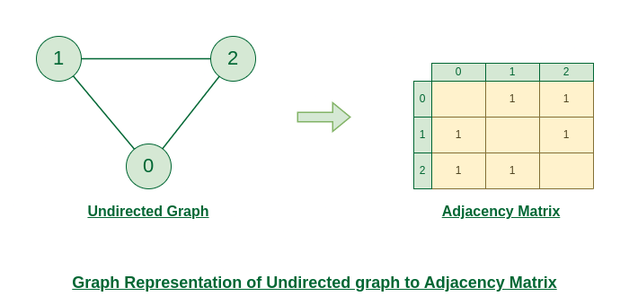
Example Graph
Consider a graph with vertices:
$$V=\{A,B,C,D\}$$
Edges:
$$E=\left\{AB,AC,BD,CD\right\}$$
Adjacency Matrix
 | A | B | C | D
A | 0 | 1 | 1 | 0
B | 1 | 0 | 0 | 1
C | 1 | 0 | 0 | 1
D | 0 | 1 | 1 | 0

Significance / Importance of Adjacency Matrix
- Easy representation of graphs in computers.
- Helps to check adjacency quickly between vertices.
- Used in graph algorithms (DFS, BFS, shortest path, etc.).
- Symmetric matrix for undirected graphs.
- Diagonal elements are zero for simple graphs (no self-loops).
- Useful for finding:
- Degree of a vertex (sum of row elements)
- Paths and connectivity
- Isomorphism testing

9. Explain graph isomorphism. State the necessary conditions for two graphs to be isomorphic and illustrate with an example.
Two graphs $G_{1}=(V_{1},E_{1})$and $G_{2}=(V_{2},E_{2})$are said to be isomorphic if there exists a one-to-one and onto mapping (bijection)
$$f:V_{1}→V_{2}$$
such that:
- Two vertices $u$and $v$are adjacent in $G_{1}$if and only if
$f(u)$and $f(v)$are adjacent in $G_{2}$.

Necessary Conditions for Graph Isomorphism
For two graphs to be isomorphic, they must satisfy the following conditions:
- Same number of vertices
$$∣V_{1}∣=∣V_{2}∣$$
- Same number of edges
$$∣E_{1}∣=∣E_{2}∣$$
- Same degree sequence
  - Degrees of vertices must be the same (when arranged in the same order)
- Same adjacency relationships
  - If two vertices are adjacent in one graph, their corresponding vertices must also be adjacent in the other graph
- Same number of connected components
  - Both graphs must be either connected or disconnected in the same way
These are necessary but not always sufficient conditions.
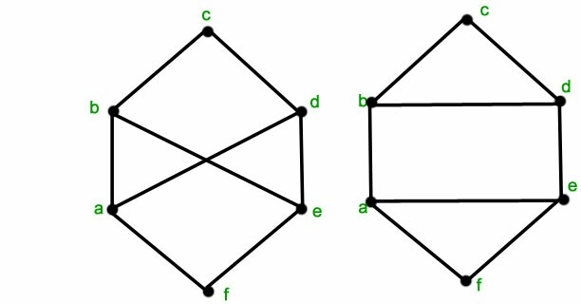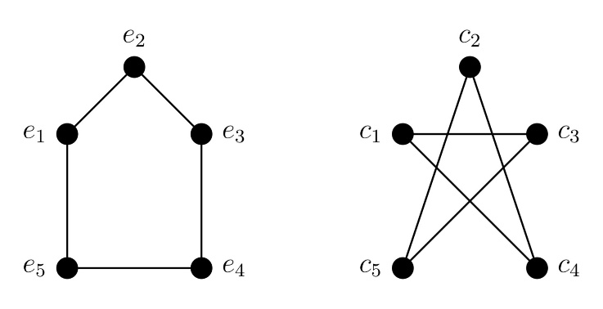

Isomorphism Mapping
$$A→1,B→2,C→3,D→4$$
- Both graphs have 4 vertices and 4 edges
- Degree of each vertex = 2
- Adjacency is preserved
Hence, $G_{1}≅G_{2}$

Example of Isomorphic Graphs
Consider two graphs $G_{1}$and $G_{2}$:
Graph $G_{1}$
Vertices: $\left\{A , B , C , D\right\}$
Edges: $\left\{AB , BC , CD , DA\right\}$
Graph $G_{2}$
Vertices: $\left\{1 , 2 , 3 , 4\right\}$
Edges: $\left\{12 , 23 , 34 , 41\right\}$

10. Define planar graph and regions of a graph. State and explain Euler’s formula. Verify Euler’s formula for a suitable planar graph and mention one application.
Planar Graph
A planar graph is a graph that can be drawn on a plane such that:
- No two edges intersect or cross each other except at their endpoints.
If a graph can be drawn without edge crossings, it is planar.
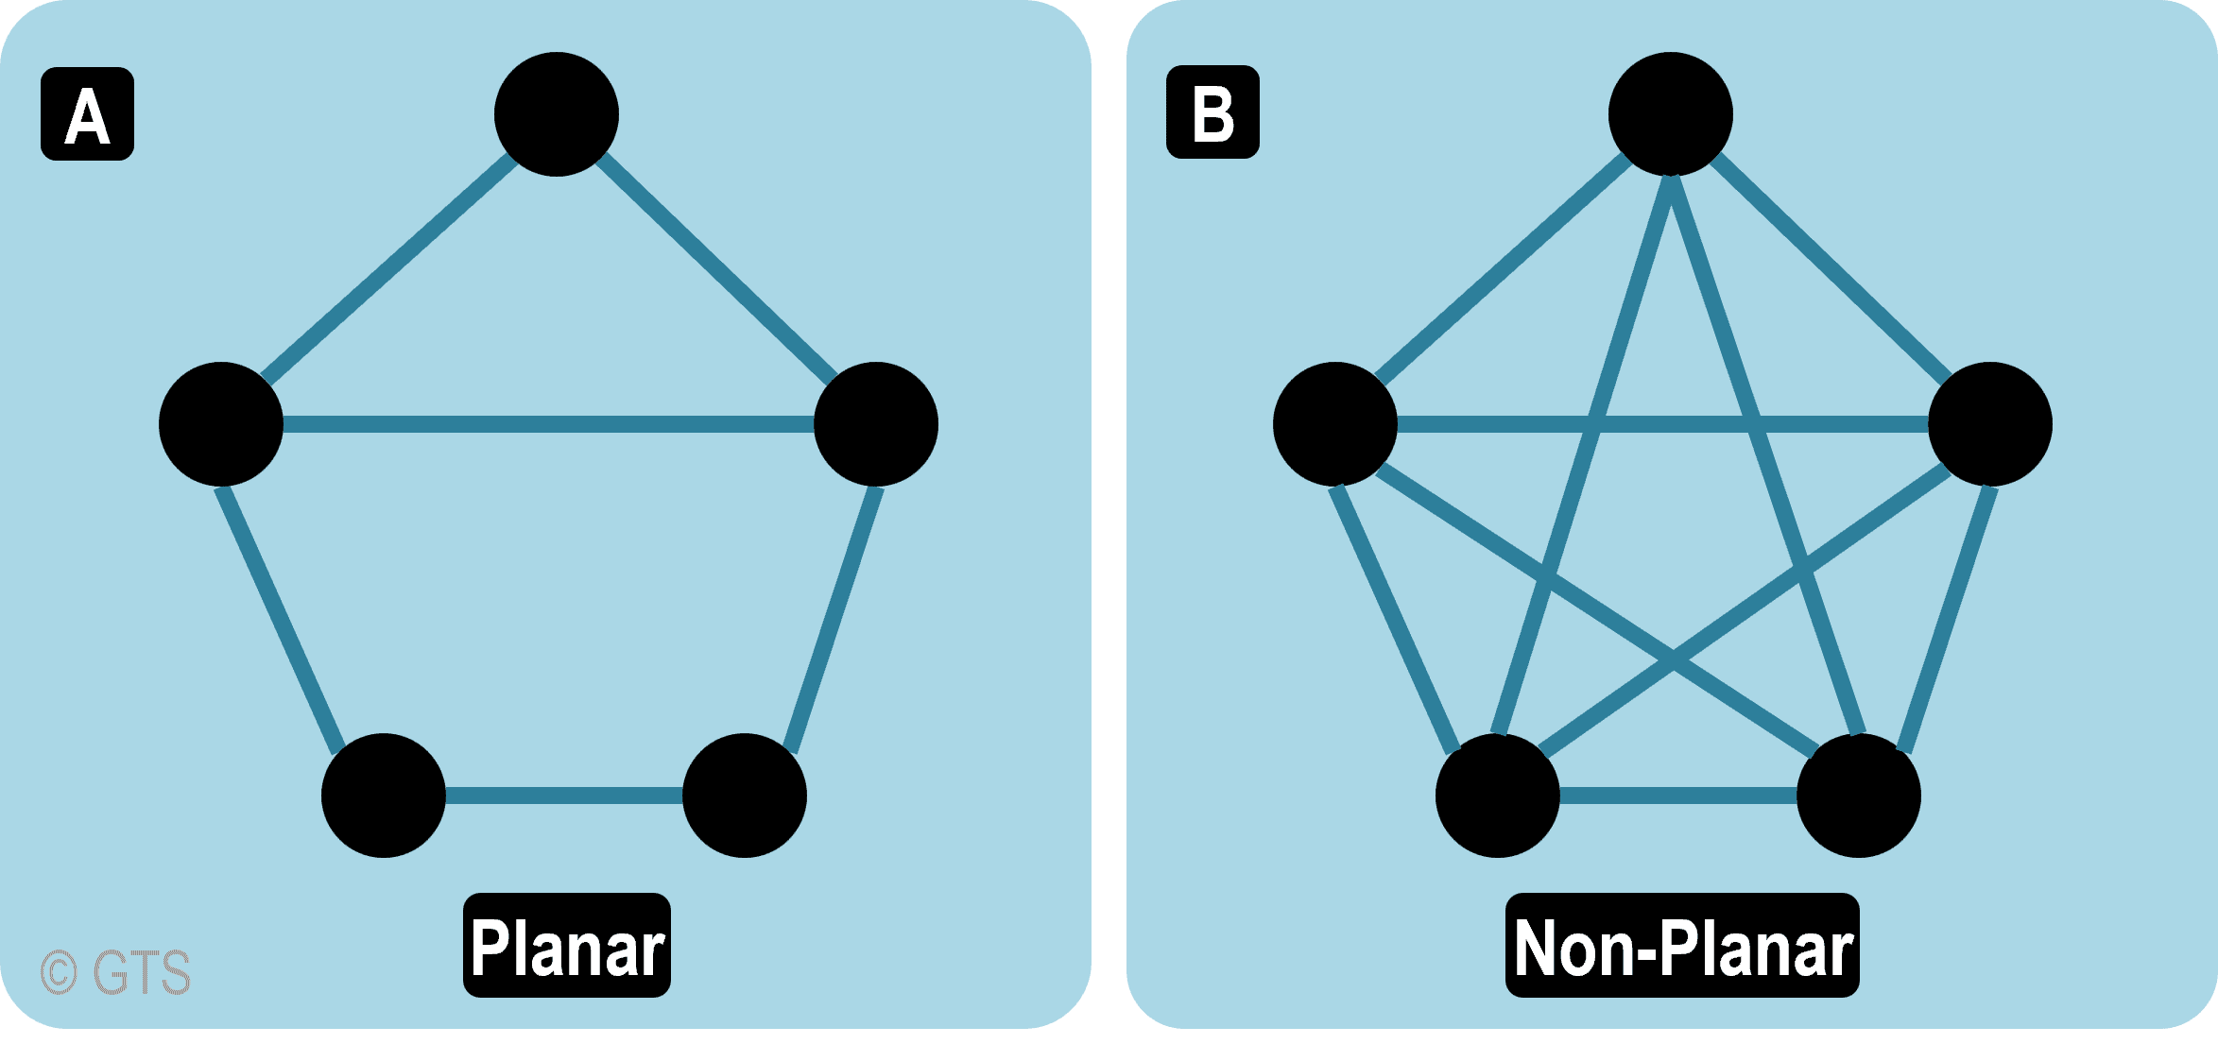
Regions (Faces) of a Graph
When a planar graph is drawn on a plane, it divides the plane into several regions (also called faces).
- Each region is an area bounded by edges.
- The outer infinite region is also counted as a region.
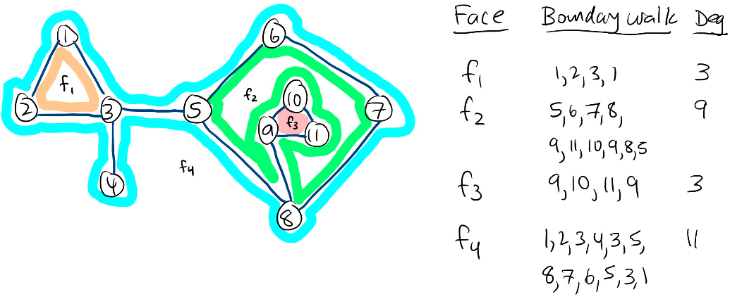
Euler’s Formula
Statement
For any connected planar graph, Euler’s formula is:
$$V-E+R=2$$
where:
- $V$= number of vertices
- $E$= number of edges
- $R$= number of regions (including outer region)
Euler’s formula establishes a fundamental relationship between the number of vertices, edges, and regions of a planar graph.
It is valid for all connected planar graphs.
Example: Triangle Graph
Consider a triangle drawn in the plane:
- Vertices $V=3$
- Edges $E=3$
- Regions $R=2$
(1 inner region + 1 outer region)
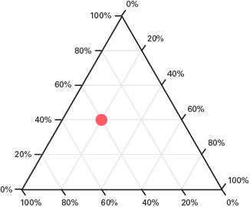
Verification
$$V-E+R=3-3+2=2✓$$
Hence, Euler’s formula is verified.
Application of Euler’s Formula
One important application is in testing planarity of graphs:
- If a graph does not satisfy Euler’s formula, it is non-planar.
Other applications:
- Map coloring problems
- Electrical circuit design
- Network topology analysis

